Introduction to Time Series and Forecasting
Forecasting
● Definition: Process of using historical data to predict future values, akin to regression in supervised learning, focusing on real-valued number predictions.
● Key Difference from Regression: Unlike regression's multiple inputs for one output, forecasting uses past signal values to predict future values.
● Business Application: Essential for reducing risks and uncertainties in business operations by predicting future events.
Time Series Data
● Definition: Measurements of a variable over time, indexed by timestamps. ● Requirements: Date/timestamp (t) and quantity (y).
● Observations: Includes sales, revenues, inventories.
● Types:
○ Univariate: Single variable data.
○ Multivariate: Multiple variables data.
● Dependency: Order is crucial; altering it changes the data structure.
Handling Missing Values:
● Rule: Time series data must not have missing values; observations need to be contiguous.
● Imputation Methods: Mean/Median, Interpolation, Moving Averages.
Method 1: Imputing Using Mean/Median:
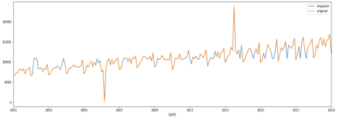● Strategy: Fill missing values with mean or median of entire dataset.
● Outcome: Sharp increments/decrements at imputed points due to global mean/median imputation.
Method 2: Linear Interpolation:
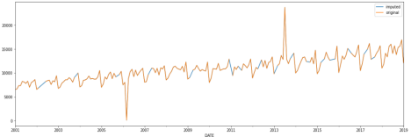● Technique: Average of points before and after missing value for imputation. ● Advantage: Prevents under/overestimation by using adjacent values. ● Outcome: Imputed values fall naturally within two finite points, avoiding forced appearance.
Handling Anomalies:
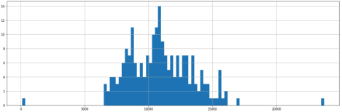
● Definition: Anomalies are abnormal data points that stand out.
● Causes: Incorrect entries or valid but rare one-time events.
● Goal: Remove to prevent model bias towards rare events.
● Methods: Fixed number replacement, quantiles, robust scaling.
● Identification: Histograms help visualize and identify outliers.
● Quantile Approach: Exclude observations beyond 95th percentile or below 5th percentile to remove anomalies.
Moving Averages:
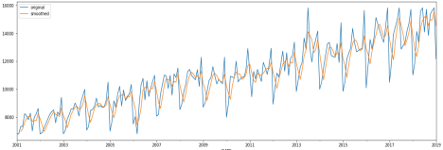Moving averages with k=3
● Definition: Average of last k data points used to predict the next point. ● Window Size (k): Acts as a hyperparameter; determines smoothness of moving average curve.
● Properties:
○ Smoothness increases with larger k.
○ Reflects trends in time series (upward or downward).
● Types:
○ Simple Moving Average: Equal weights to past observations.
○ Weighted Moving Average: Different weights to past observations.
○ Centered Moving Average: Averages points before and after current point; not suitable for forecasting due to future data requirement.
● Applications: Forecasting, anomaly detection, handling missing values.
Time Series Decomposition:
● Purpose: Splits time series into components, each representing underlying patterns. ● Components:
○ Trend: General movement over time.
○ Seasonality: Patterns within seasonal periods.
○ Residual: Variations not explained by trend or seasonality.
● Characteristics: Trend and seasonality are systematic; Residual is irregular.
Trend:
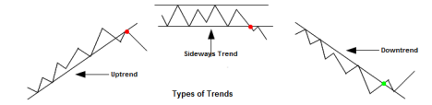● Definition: Linear increase or decrease in series over time, non-repetitive. ● Types: Uptrend, downtrend, fluctuating.
● Trend Line: Smooth function tracing series trend, aids in future predictions. ● Calculation: Rolling/moving average or Linear Regression fitting.
Seasonality:
● Definition: Regular pattern in data at specific intervals (e.g., yearly, weekly). ● Characteristics: Occurs due to seasonal factors like time of year or week. ● Calculation Steps:
○ Subtract trend from original series.
○ Average results over each period (e.g., monthly averages over years).
● Note: Yearly series lack seasonality; possible to have multiple seasonalities (short-term and long-term).
Irregular Component:
● Definition: Random fluctuation in time series not explained by trend or seasonality. ● Characteristics: Assumed normal distribution, 0 mean, constant variance. ● Also Known As: Error, White Noise, Remainder.
Additive Decomposition:
● Formula: Time Series = Trend (b(t)) + Seasonality (s(t)) + Error (e(t)). ● Characteristics:
○ Error (e(t)) computed from actual values, scattered around zero if estimates are accurate.
○ Seasonal fluctuations independent of trend, constant seasonality.
Multiplicative Decomposition:
● Principle: Seasonal amplitude increases with trend.
● Formula: Time Series = Trend (b(t)) * Seasonality (s(t)).
● Characteristic: Seasonal fluctuations dependent on trend.

